Access to the COVID Vaccination Clinic

The COVID vaccination clinic is located within the Mike Hannon Suite at Orford Jubilee Neighbourhood Hub (WA2 8HE)

Direct bus route is via the 22A service

PLEASE NOTE: The COVID vaccination clinic CANNOT be accessed via the main entrance of the Orford Jubilee Hub building. Access is via the rear entrance, as shown in the map below.

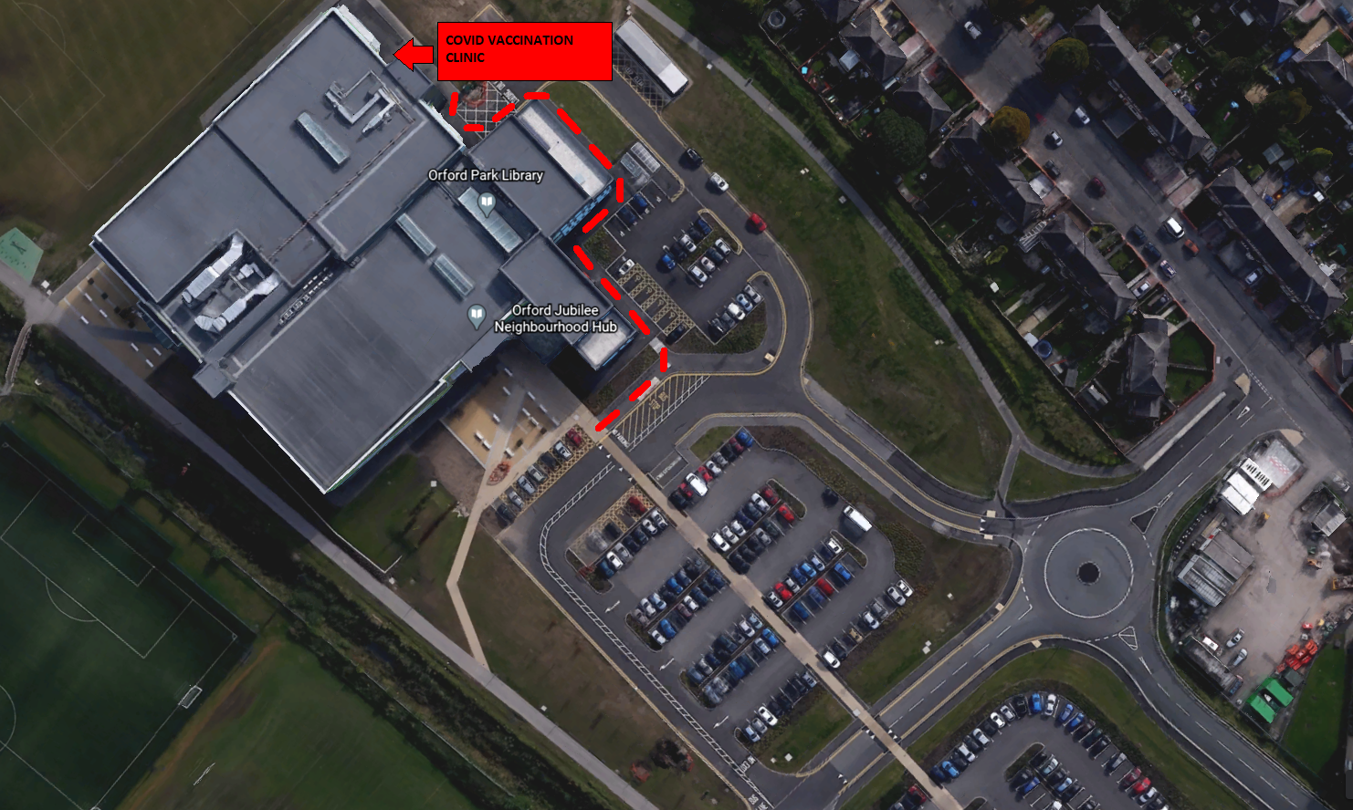

What is COVID-19 or coronavirus?
COVID-19 is caused by a new coronavirus, known as SARS-CoV-2. It was first identified in late 2019. It is very infectious and can lead to severe respiratory disease.

Many people who are infected may not have any symptoms or only have mild symptoms. These commonly start with cough, fever, headache and loss of taste or smell.

Some people will feel very tired, have aching muscles, sore throat, diarrhoea and vomiting, fever and confusion. A small number of people then go on to have severe disease which may require hospitalisation or admission to intensive care.

Overall fewer than 1 in 100 people who are infected will die from COVID-19, but in those over 75 years of age this rises to 1 in 10.

There is no cure for COVID-19 although some newly tested treatments do help to reduce the risk of complications.

About the types of vaccine
In the UK, there are 2 types of COVID-19 vaccine to be used once they are approved. They both require 2 doses to provide the best protection.

Who should have the COVID-19 vaccines
The Joint Committee on Vaccination and Immunisation (JCVI), an independent expert group, has recommended that the NHS offers these vaccines first to those at highest risk of catching the infection and of suffering serious complications if they catch the infection.

This includes older adults, frontline health and social care workers, care home residents and staff, and those with certain clinical conditions. When more vaccine becomes available, the vaccines will be offered to other people at risk as soon as possible.

Are you at increased risk from COVID-19 infection?
Coronavirus can affect anyone. If you are an older adult and have a long-term health condition, COVID-19 can be very serious and in some cases fatal.

You should have the COVID-19 vaccine if you are:
- an adult living or working in a care home for the elderly
- a frontline healthcare worker
- a frontline social care worker
- a carer working in domiciliary care looking after older adults
- aged 65 years and over
- younger adults with long-term clinical conditions (see conditions below)

The vaccine will also be offered to adults with conditions such as:
- a blood cancer (such as leukaemia, lymphoma or myeloma)
- diabetes
- dementia
- a heart problem
- a chest complaint or breathing difficulties, including bronchitis, emphysema or severe asthma
- a kidney disease
- a liver disease
- lowered immunity due to disease or treatment (such as HIV infection, steroid medication, chemotherapy or radiotherapy)
- rheumatoid arthritis, lupus or psoriasis
- liver disease
- have had an organ transplant
- had a stroke or a transient ischaemic attack (TIA)
- a neurological or muscle wasting condition
- a severe or profound learning disability
- a problem with your spleen, example sickle cell disease, or having had your spleen removed
- are seriously overweight (BMI of 40 and above)
- are severely mentally ill

All people who are in the Clinically Extremely Vulnerable group will be eligible for a COVID-19 vaccine. Whether you are offered the vaccine may depend on the severity of your condition. Your GP can advise on whether you are eligible.

Those who cannot have the vaccine
The vaccines do not contain living organisms, and so are safe for people with disorders of the immune system. These people may not respond so well to the vaccine. A very small number of people who are at risk of COVID-19 cannot have the vaccine – this includes people who have severe allergies to a component in the vaccine.

Women of childbearing age, those who are pregnant, planning a pregnancy or breastfeeding should read the detailed information available on NHS.UK.

Will the vaccine protect you?
The COVID-19 vaccination will reduce the chance of you suffering from COVID-19 disease. It may take a few weeks for your body to build up protection from the vaccine.

The vaccine has been shown to be effective and no safety concerns were seen in studies of more than 20,000 people.

Like all medicines, no vaccine is completely effective – some people may still get COVID-19 despite having a vaccination, but this should be less severe.

Side effects
Like all medicines, vaccines can cause side effects. Most of these are mild and short term, and not everyone gets them. Even if you do have symptoms after the first dose, you still need to have the second dose. Although you may get some protection from the first dose, having the second dose will give you the best protection against the virus.

Very common side effects include:
- having a painful, heavy feeling and tenderness in the arm where you had your injection. This tends to be worst around 1-2 days after the vaccine
- feeling tired
- headache
- general aches, or mild flu like symptoms

Although feeling feverish is not uncommon for 2 to 3 days, a high temperature is unusual and may indicate you have COVID-19 or another infection. You can rest and take the normal dose of paracetamol (follow the advice in the packaging) to help you feel better.
Symptoms following vaccination normally last less than a week. If your symptoms seem to get worse or if you are concerned, call NHS 111.

If you do seek advice from a doctor or nurse, make sure you tell them about your vaccination (show them the vaccination card if possible) so that they can assess you properly.

You can also report suspected side effects to vaccines and medicines online through the Yellow Card scheme.

I have had my flu vaccine, do I need the COVID-19 vaccine as well?
The flu vaccine does not protect you from COVID-19. As you are eligible for both vaccines you should have them both, but normally separated by at least a week.

Can you catch COVID-19 from the vaccine?
You cannot catch COVID-19 from the vaccine but it is possible to have caught COVID-19 and not realise you have the symptoms until after your vaccination appointment.

The most important symptoms of COVID-19 are recent onset of any of the following:
- a new continuous cough
- a high temperature
- a loss of, or change in, your normal sense of taste or smell

If you have the symptoms above, stay at home and arrange to have a test. Further information on symptoms is available on NHS.UK.

What to do next
After you have had the first dose you need to plan to attend your second appointment. You should have a record card with your next appointment written on it for an appointment in 21 or 28 days.

It is important to have both doses of the vaccine to give you the best protection.

Keep your record card safe and make sure you keep your next appointment to get your second dose.

If you are not well when it is your next appointment
If you are unwell, it is better to wait until you have recovered to have your vaccine, but you should try to have it as soon as possible. You should not attend a vaccine appointment if you are self-isolating, waiting for a COVID-19 test or unsure if you are fit and well.

Can you give COVID-19 to anyone, after having the vaccine?
The vaccine cannot give you COVID-19 infection, and 2 doses will reduce your chance of becoming seriously ill. We do not yet know whether it will stop you from catching and passing on the virus. So, it is important to follow the guidance in your local area to protect those around you.

To protect yourself and your family, friends and colleagues you still need to:
- practice social distancing
- wear a face mask
- wash your hands carefully and frequently
- follow the current guidance

How COVID-19 is spread
COVID-19 is spread through droplets breathed out from the nose or mouth, particularly when speaking or coughing. It can also be picked up by touching your eyes, nose and mouth after contact with contaminated objects and surfaces.

